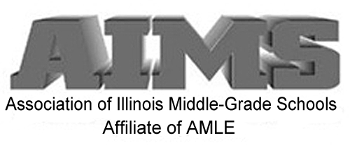

**Registration begins at 8:30 a.m.**

**Conference ends at 2:30 p.m.**

##### Event Registration Fees (includes breakfast & lunch):

##### - AIMS Members: $75

##### - Non-Members Registration: $100

**- Student rate: $30**

**- Special rates for NLU students and staff.**

**For payments by check or PO: use attached form.**

**For payments by credit card use: www.aimsnetwork.org**

**Group Registration Rates Available.**

##### 

**The AIMS Network Institute will showcase Middle Schools around the state. We will celebrate success and share best practices in Middle School education.**

**Presentation sessions will focus on: Google Classrooms, Project Based Learning, Breakout#EDU, Next Generation Science Standards, Digital Portfolios, Standards Based Reporting, Instruction with #Hyperdocs and more…This is a conference presented by practitioners for practitioners.**

**This event will offer an excellent opportunity for administrators and their new staff members to observe the best in middle school practices together. It will also provide networking opportunities to all those in attendance.**

**Additional information can be found on our website:** [**aimsnetwork.org**](http://aimsnetwork.org)**.**

AIMS Network Institute

**S.T.A.R.S. Re-Connect Conference**

Thursday, December 1, 2016

National Louis University

850 Warrenville Road Lisle, IL 60532

### **S.T.A.R.S.**

**S – Sharing**

**T- Tools for**

**A – Achievement &**

**R – Recognition in our**

**S – Schools**

*Please direct any inquires to:*

*John Viano, AIMS Executive Director*

3712 N. Broadway

Suite 180

Chicago, IL 60613

T (872) 216-5254

Web: [www.aimsnetwork.org](http://www.aimsnetwork.org)

AIMS

3712 N. Broadway

Suite 180

Chicago, IL 60613

T (872) 216-5254

Web: [www.aimsnetwork.org](http://www.aimsnetwork.org)

*r;*

AIMS

3712 N. Broadway

Suite 180

Chicago, IL 60613

T (872) 216-5254

Web: [www.aimsnetwork.org](http://www.aimsnetwork.org)

##### Quisque

|  |  |
| --- | --- |
| AIMS NETWORK INSTITUTE  Thursday, December 1, 2016  Registration Form | National Louis University  Lisle Campus  850 Warrenville Road  Lisle, IL. 60532 |

|  |  |
| --- | --- |
| Name: |  |
| E-mail: |  |
|  |  |
| Name of School: |  |
| Street Address: |  |
| City, Zip |  |
| Telephone Number: |  |
| Group: | Provide names of people in your group: List additional group members on a separate page. |
| Name: |  |
| Name: |  |
| Name: |  |

|  |
| --- |
| Payment information:  AIMS Members: $75  Non-Members: $100  Student Members: $30 |
| ( ) Paying by Credit Card – Please go to our secure online payment at: www.aimsnetwork.org |
| ( ) PO # Please mail to address below |
| ( ) Check – Please mail to address below |

Association of Illinois Middle-Grade Schools

3712 N. Broadway Suite 180

Chicago, Illinois 60613

Website: [www.aimsnetwork.org](http://www.aimsnetwork.org)