

Wednesday, April 12, 2017

Time: 9:00 a.m. Registration & Refreshments

Discussion: 9:30 a.m.

Cost: FREE

**Please direct any inquiries to:**

**John Viano, AIMS Executive Director;**

**Association of Illinois Middle-Grade Schools**

**3712 North Broadway**

**Suite 180**

**Chicago, Illinois 60613**

**T** [**(872) 216-5254**](tel:%28872%29%20216-5254)

**web:** [**www.aimsnetwork.org**](http://www.aimsnetwork.org)

**email:** [**jviano13@gmail.com**](mailto:jviano13@gmail.com)

Location: Belvidere South Middle School

919 East Sixth Street

Belvidere, IL 61008

Host: Megan Johnson

### APAPCD Roundtable

The Association of IL Middle-Grade Schools is planning another Middle School Administrators Roundtable session for Wednesday, April 12, 2017.

Discussion topics will focus on Middle School Advocacy. Additional talking points will be determined by your input regarding items of interest or urgency.

This is an AIMS FREE event. Please indicate your interest in attending this event by sending an email message to: **jviano13@gmail.com.**

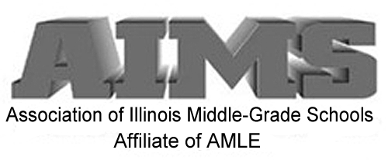

AIMS

A-Administrators, P-Principals, AP-Assistant Principals, CD-Curriculum Directors (APAPCD)

“*Roundtable”* Discussion Series